2.52: a) 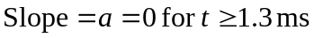
b) 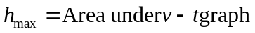
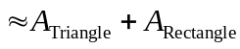
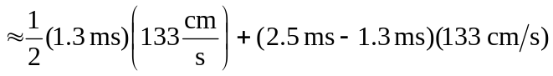
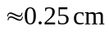

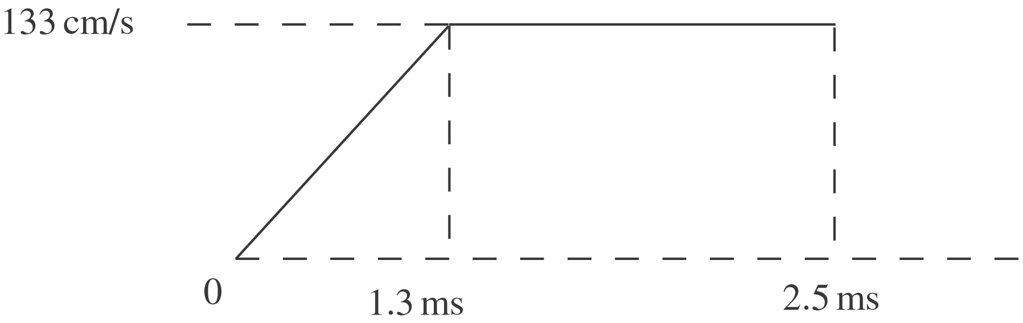
c) a = slope of v– t graph

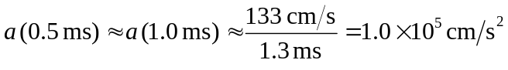

d) h = area under v– t graph

